Sample of PhysicalVerification Pictures.

The table below illustrates some physical status of the verified assets with photographic evidence.
Table XXX: Physical verification photos
ETAM SEED SCHOOL FULL VIEW | 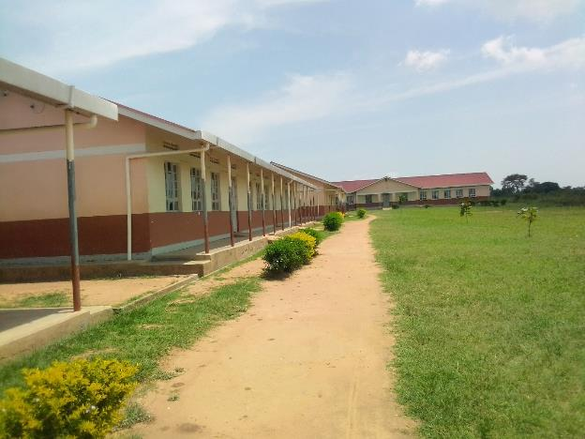
LIBRARY | 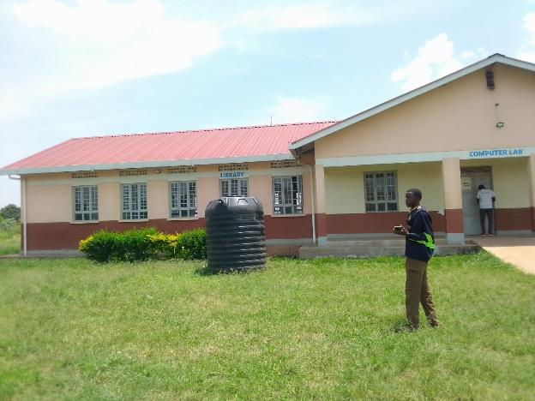
COMPUTER LAB | 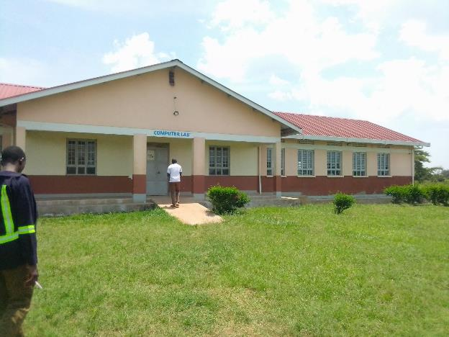
KITCHEN STAFF QUARTERS | 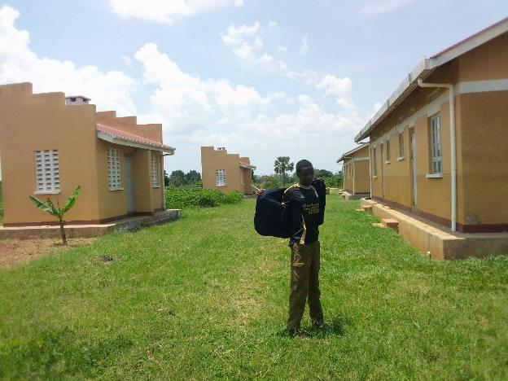
TOILETS | 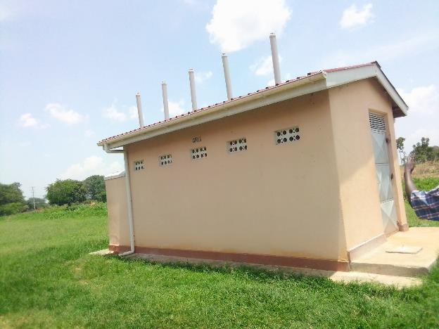
2 UNIT BLOCK  STAFF QUARTERS | 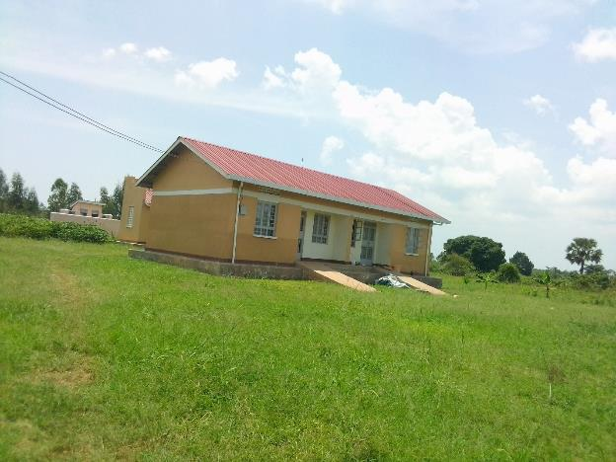
ENGRAVED CHAIR | 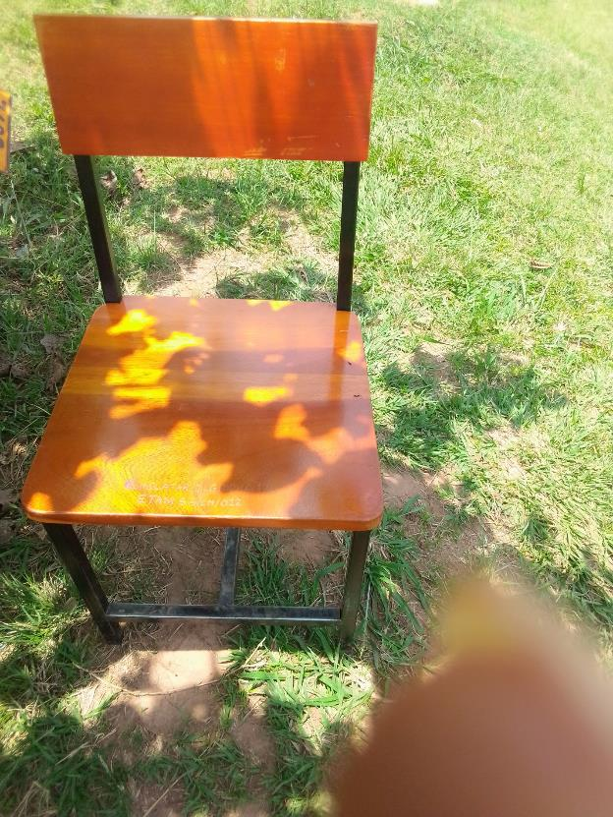
TABLES AND CHAIRS | 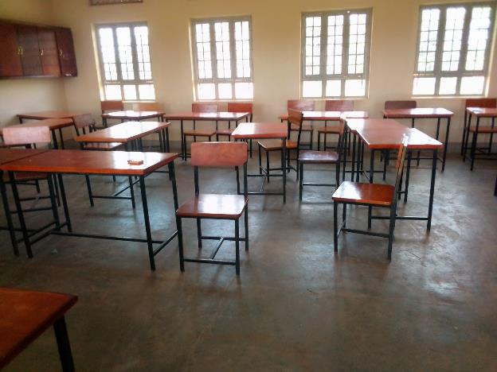
DESKS | 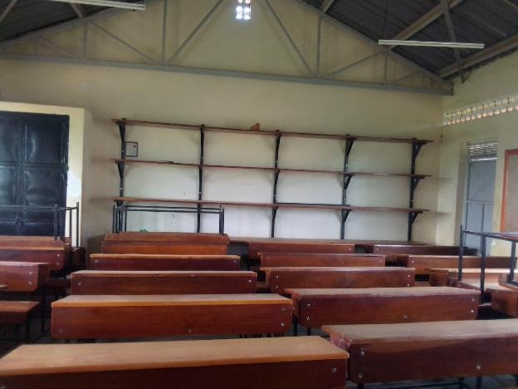
DESK ENGRAVEMENT | 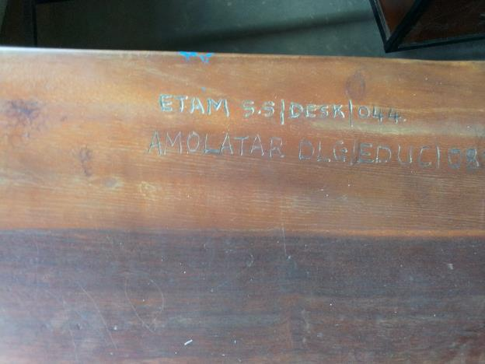
OFFICE DESK | 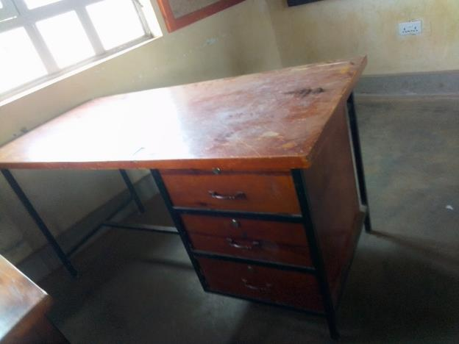
PLAY GROUND | 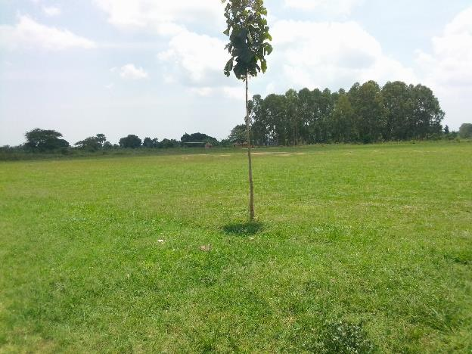
PROJECTOR | 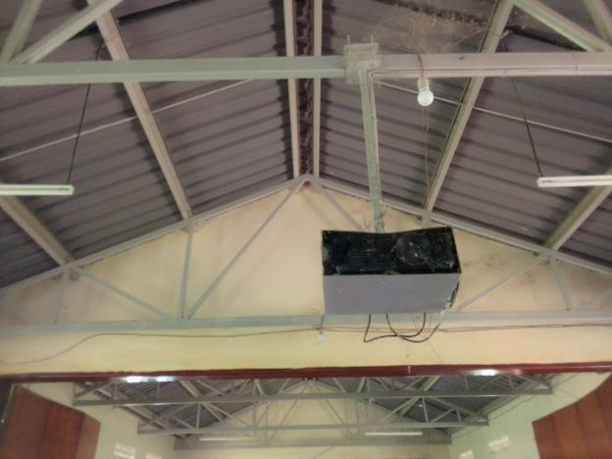
UPS FOR SERVER | 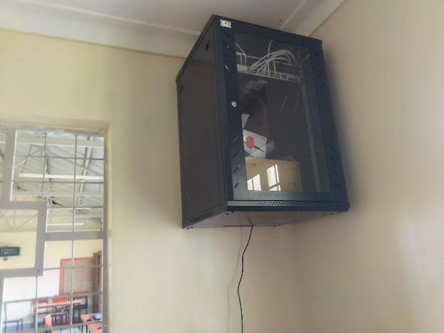
WELL ENGRAVED COMPUTER (MONITOR | 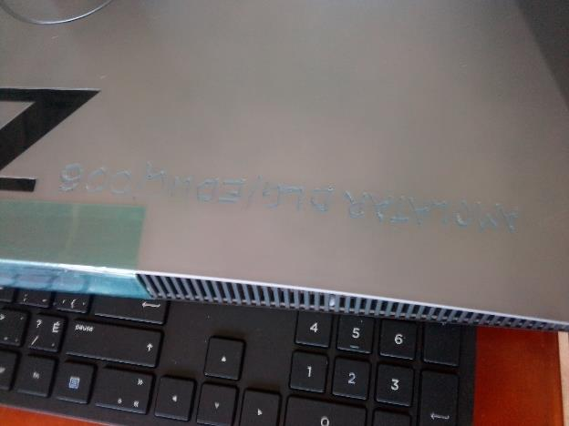
UPS | 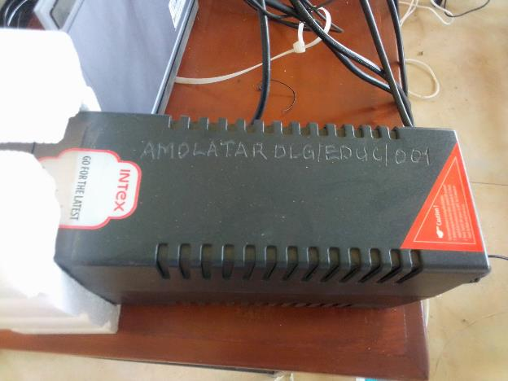
FIRE EXTINGUSHIER | 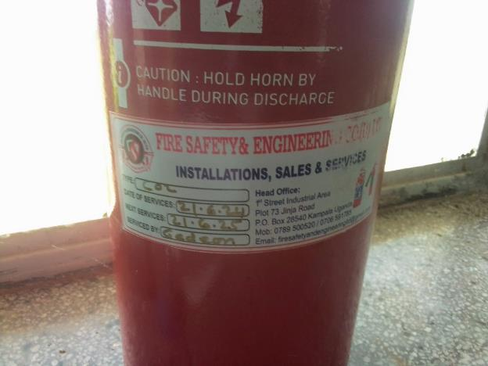
COMPUTERS IN THE ICT LABORATORY | 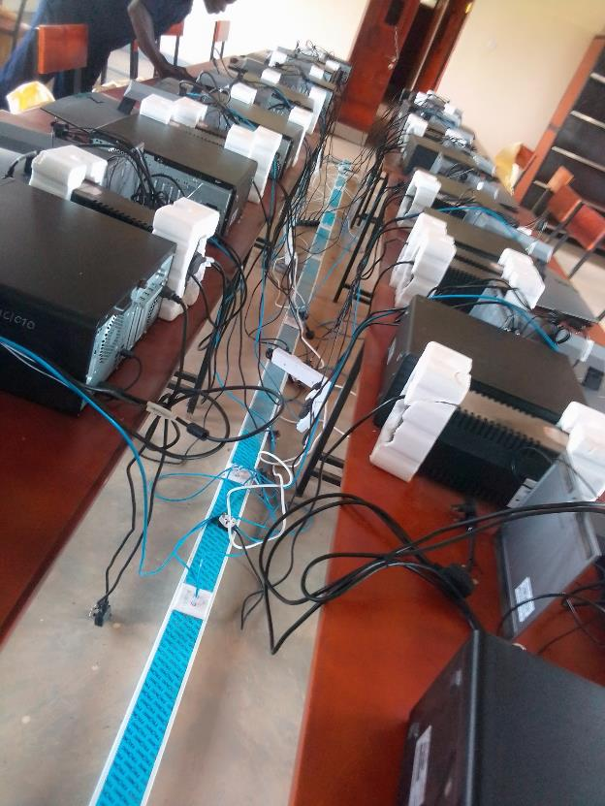
AIR CONDITIONER | 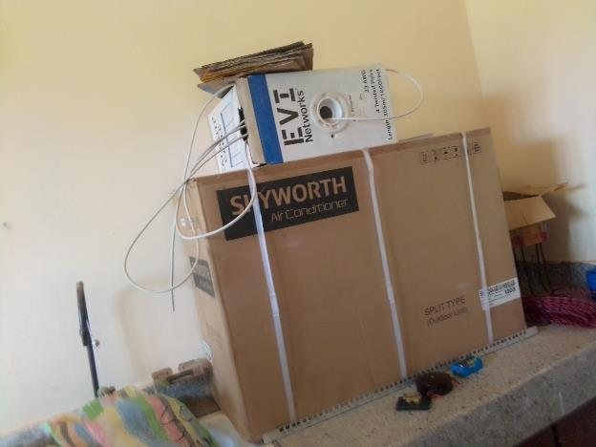
WATER TANK | 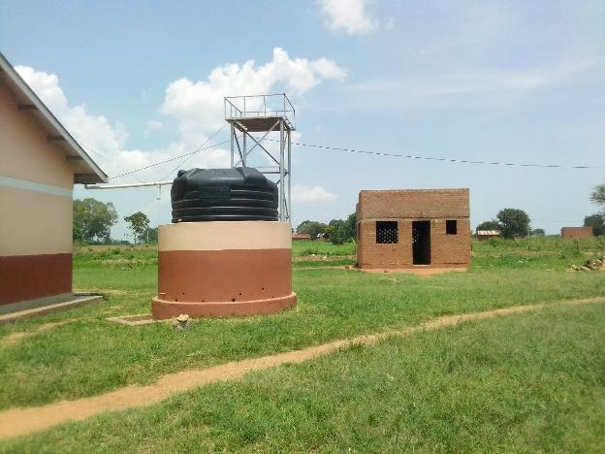
ENGRAVES STOOLS | 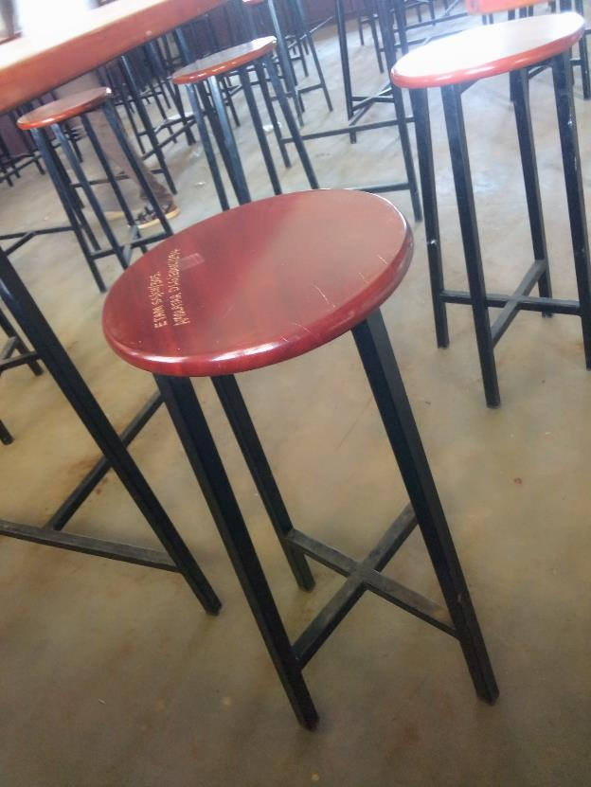
DJ BOOTH / AMPLIFIER | 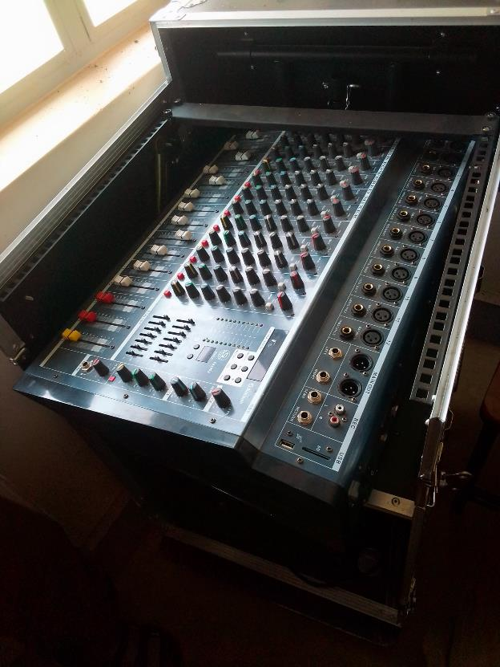
SPEAKER | 